Name: _______Mary Oh________

Student ID: ____1208315416____

Date: ________04.01.18________

**Instructions:** Answer the following questions using complete sentences. You should use these questions to have a written discussion about the website you are going to design for the topic you submitted for Project Submission 1.

**Website Goal***Describe the goal of your website in one or two sentences.*

The goal of my website is to inform people about the EKG Heart Monitoring system.

**What results do I want to see?***List the working title and a brief description of each page on your site. You will need to have seven to eight titles/descriptions listed.*

* Home page – quick overview of the EKG Heart Monitoring Project
* Why it’s done/needed – this page will talk about the problem this Heart Monitoring Project is trying to solve
* How it’s done – this page will talk about the process of creating the project
* What’s expected – this page will talk about the risks and results that can be expected
* Procedure – it will contain information on how to obtain the monitoring system and how to use it
* Physicians/doctor’s access page – this is only for doctors to be able to access data recorded and uploaded on cloud
* FAQ – quick troubleshoot information as well as answers to some common asked question
* About us/contact us – it will contain all information about who is involved in the project and such. This will also have a form to where people can contact us for questions.

**What information do I need?**  
*List where you will obtain the content (facts, text, graphics, sound, video, etc.) for the web pages you listed above. List out this information separately for each page you listed above.*

The home page, why it’s done/needed, how it’s done, what’s expected, procedure, FAQ, and about us are all going to be information obtained or researched for the project. As of the moment, the project is still in progress, so as the project progress, more and more information will be obtained to be added to the website. All medias are going to be taken from the process of building the project as well, some of it will be data collected from testing, videos from building the project, and such. As for the physician’s access page, this will kind of like a login page to access data from database, so basically information for this page will be coming from an actual user’s cloud.

**What color scheme will you use for your site?**

*Go to paletton.com and select a color scheme your like. Play around with the different type of color combinations.* ***Choose a Triad or Tetrad combination, this will provide you will several colors for your website.*** *When you find one that you like, click “share palette” in the top right corner and copy the Pallet UID and the image and paste it in the space below. Example is on the next page.*

[71u1o1k7UUa3cZA5wXlaiQ5cFL3k7UUa3cZA5wXlaiQ5cFL3k7UUa3cZA5wXlaiQ5cFL3kwi++bu++hX++++rd++kX](http://paletton.com/#uid=71u1o1k7UUa3cZA5wXlaiQ5cFL3k7UUa3cZA5wXlaiQ5cFL3k7UUa3cZA5wXlaiQ5cFL3kwi++bu++hX++++rd++kX)

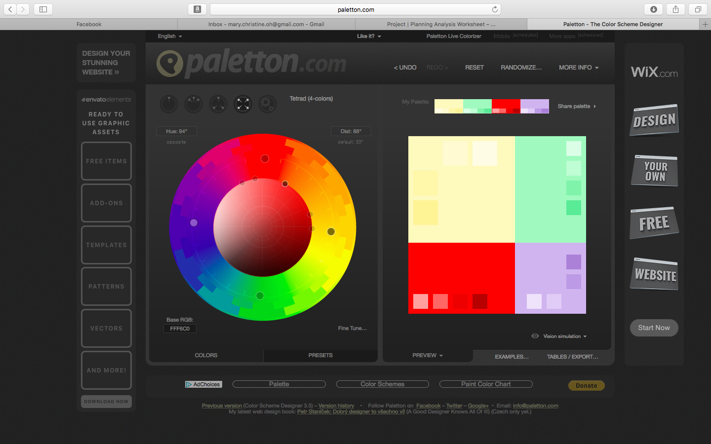

**How will your project use a form?**

*Describe how you plan to use a form in your project to collect information. Examples of using a form might be to offer feedback, provide a survey or poll, offer subscriptions to a newsletter, etc. Describe what information you will want to collect and the importance of each piece of information.*

My project will have a form where people can fill that up to ask questions they may have.

Color Scheme Example:

Palette UID: [6300E0kuDsfjIzJoXu+wmmFDMh-](http://paletton.com/#uid=6300E0kuDsfjIzJoXu+wmmFDMh-)

[](http://paletton.com/%23uid=6300E0kuDsfjIzJoXu+wmmFDMh-)